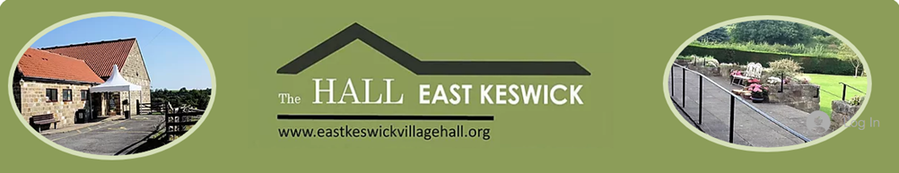

East Keswick Village Hall Gift Aid

I would like the East Keswick Village Hall to treat all donations and subscriptions I have made in the previous four years, and any made from this date as Gift Aid donations until I notify you otherwise.

I am a UK taxpayer and understand that if I pay less Income Tax and/or Capital Gains Tax in the current tax year than the amount of Gift Aid claimed on all my donations, I am responsible for paying any difference.

Full Name:
Email Address:
Postal Address: |  | Post Code:
Date:

*Please complete in block capitals letters

